Activity
Instructions

King-Devick’s

Addresses saccadic functions, visual tracking, and visual processing speed. Note: This is not the standardized test version, simply a sample of Test III.

Client reads numbers from left to right as quickly as possible without making mistakes. Time trials and keep track of accuracy.
Progression:
- Highlight lines to assist with tracking
- Begin with monocular trials and progress to binocular trials once time between eyes is consistent, or approval granted from optometrist
- Introduce finger tracking to assist with anchoring
- Remove highlighted lines and finger tracking strategy

Red/Green Filtered Lenses

Addresses anti-suppression and binocular eye teaming.

Have client don red/green filtered lenses. Utilize bar readers for reading text, word searches, etc. TV filters can be used for iPad, TV screens for Wii activities or general viewing, over computer screen, or on paper/pencil tasks. Playing cards can be used for any general card game to integrate motor performance with eye teaming.

Tip: to simulate suppression, close one eye while completing these tasks to have half of the information disappear.

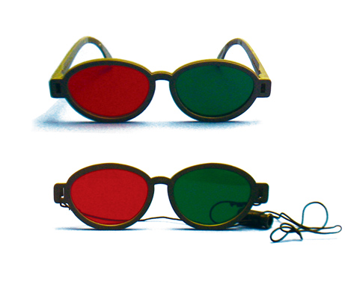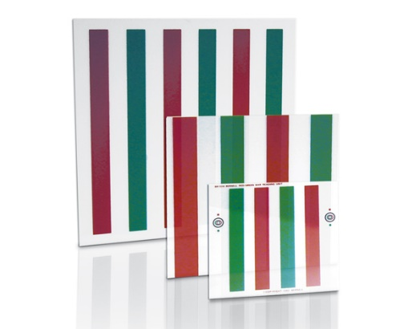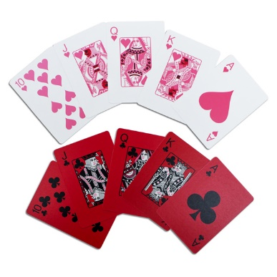

Polarized Bar Readers

Addresses stereopsis, anti-suppression, and binocularity.

Have clients don polarized lenses and place bar readers over activity (paper/pencil tasks, iPad, computer screen, reading material, etc.). Should be able to see through grayed bars without strain.
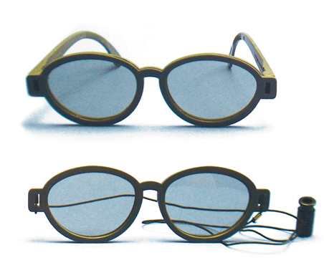
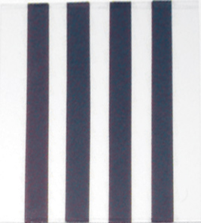

Carl’s Cards

Addresses suppression, binocular eye teaming, visual matching and discrimination, and visual memory.

Have client don red/green filtered lenses. Each card has a match of opposite color, so both eyes must work together as a team to see both cards. See below for different activity ideas.
- Memory: classic memory activity. Flip cards upside down and locate the matches by flipping the cards two at a time.
- Matching: spread one of each match out on table top, floor, on walls along a hallway, on large therapy room wall, etc. Hand client one card at a time and have he or she look for the match.
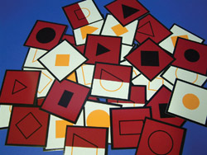

Bead Brock String
Addresses convergence, divergence, anti-suppression, physiological diplopia.

Place three colored beads on a string, with or without accommodative focal points, approximately 12 inches apart. Have client hold the string up to his or her nose and first converge eyes on nearest bead. Instruct that he or she should see one (green) bead, and the string splitting to a “V” behind that bead. He or she should see two of the other colored beads. Hold this posture for five seconds, and progress to the other beads. Sequence through this for up to five minutes if able to do so without increased eye strain or pain.
Progression:
- Begin with beads places 12 inches apart. Move further apart if jumps are too difficult. As the client progresses with comfort level, move beads closer together.
- Increase the amount of time for sequencing through the beads.
- Change angle to string (inferior or superior gaze) for increased comfort or challenge.
- Rotate string slowly clockwise and counter-clockwise while client sequences through beads.
- Add a metronome for added rhythmic demands.
- Use one bead and start at 2-inches from the end of the nose. Slowly move the bead down the string, maintaining fusion on the bead and splitting the string in front of and behind the bead to create an “X” all the way down the string.
- Add accommodation flippers for added accommodation facility practice.
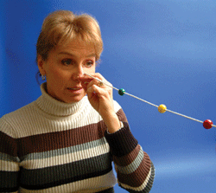
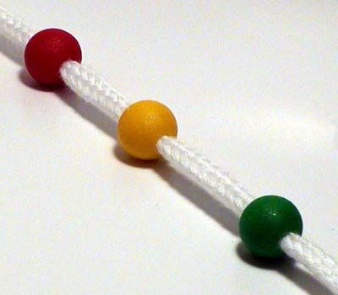

3D Tranaglyph Rings

Addresses anti-suppression, binocular eye teaming, stereopsis, convergence, and divergence.

Have client don red/green filtered lenses. Place 3D rings in front of a simple background or window. Have client stand 5 feet from chart with prism placed over the eye base-out (convergence). Have the client step backwards up to 10-12 feet, indicating if the ring appears to be coming toward them or away from them. The circle, X, and square should be aligned as well. Repeat with base-in (divergence).
Progression:
- Start with #2 or #4 prism, working to greater diopter strengths as the client progresses without strain, up to #12 (for #10 and higher combine prism strengths – i.e.: 4+6).
- Change direction of rings chart to check for accuracy and fusion.
- Complete jumps between base-out and base-in for larger flexibility in vergence ranges.
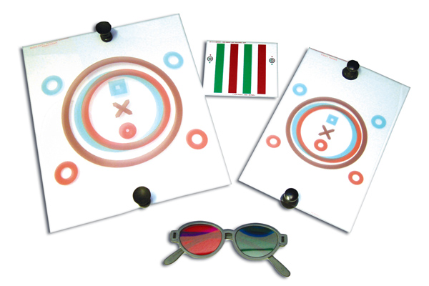

Prisms
Addresses vergence ranges, flexibility, and vergence insufficiency. Can be utilized as an eye positioning compensation as well. Note: OTs must have script to utilize prisms in therapy plans.
- Convergence Insufficiency: Strengthen posture muscles by utilizing a base-out prism over one eye while working on near work task (iPad, computer, reading, paper/pencil, tabletop games, etc.)
- Vergence Facility and Flexibility: Flip prism from base-out to base-in at timed or random intervals and encourage single vision with fusion. This can be completed with a variety of near work tasks or free space gross motor tasks.
- Monocular Prism Jumps: Have client don eye patch and look across room to a small, discrete visual target. Tell the client that you will place a prism over his or her eye that will move the target left, right, up, or down, and have them respond with the direction. Start with a #10 prism, and with accurate responses remove the prism and complete again in different directions, progressing to lower and lower prisms until the responses become guesses. Record the lowest number prism he or she is able to respond correctly to. If incorrect, ask him or her to try again after removing the prism and watch for eye movements to provide feedback.
- Compensatory Approach: With moderate to severe convergence insufficiency, a low diopter base-in prism may be used for a more comfortable eye posture while addressing visual perceptual or visual motor integration tasks to reduce eye strain/pain and/or suppression.
Progression:
- Start with low prism diopter (#1 or #2) and progress higher as fusion is easily obtained and maintained. Do not use greater than a #10 diopter prism in therapy treatment.
- In vergence facility tasks, complete tasks at longer durations and slowly decrease time with each side with success and comfort. Can also close eyes during flipping of the prism initially to reduce eye strain.
Note: Combine prisms for any strength greater than 6 diopters due to distortion of images.
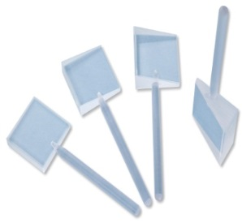

Sports Vision Slides

Addresses anti-suppression, binocular eye teaming, convergence, and divergence.

Have client don red/green filtered lenses. Place slides flat on table with light background, or onto an easel aligned at midline. Slowly move cross slides for convergence (left slide sliding to the right). Client should fuse slides together for 3D effect of images, keeping circle, X, and square aligned. Repeat for divergence.
Progression:
- Complete convergence, rest eyes, and then complete divergence
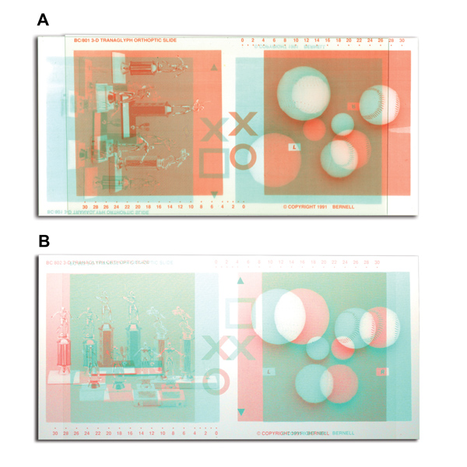
- Progress to smooth transitions between convergence and divergence

Aperture Rule

Addresses convergence and divergence, muscle memory, and binocular eye teaming.

Convergence: Place single window at 1&2. Place cards at Zero, starting with card #1. Instruct client to converge two separate images together, with the fusion check of small rings with a dot above and below. (Explain as if “crossing the eyes”). Follow slider placement as indicated on cards.
Divergence: Place double window at 1&2. Same concepts as convergence.
Progression:
- If unable to fuse images utilize a pointer for kinesthetic awareness of the eye positioning.
  - Convergence – place pointer directly behind aperture window
  - Divergence – place pointer behind cards
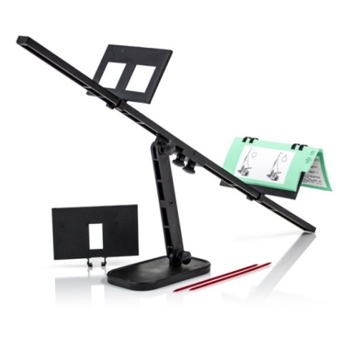

Cheiroscope Trainer

Single Oblique Mirror Stereoscope. Addresses suppression, convergence, divergence, binocular eye teaming, and visual-motor integration.

Vergence: Place card in clip to see with mirror, place opposite card at midline. Look through lenses, slowly move bottom card for convergence. Repeat for divergence. Client should be able to fuse images together with small rings fused.

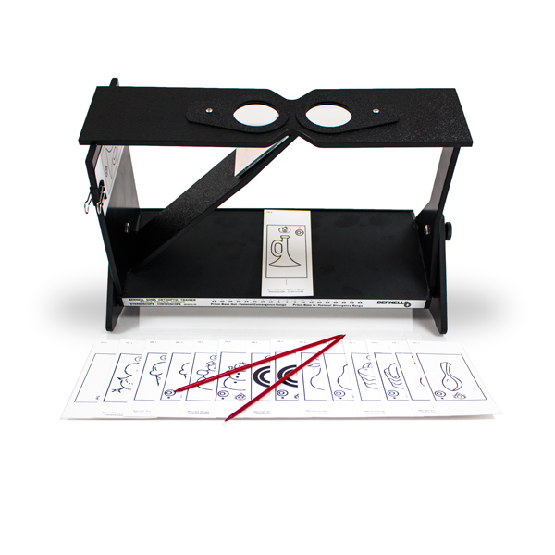
Suppression and motor integration: Place target picture card in clip to see with mirror. Place blank sticky note at bottom at midline (or adjusted to base-out or base-in for alignment shift). Instruct client to draw the image onto the sticky note as accurately as possible.

Vectograms

Addresses stereopsis, binocularity, vergences, anti-suppression, and eye posture.

Have client don polarized lenses. Start with slides in midline, moving in single diopter increments base-out, then base-in. Ensure client can see the L and the R and a single 3D image.
Progression:
- Complete larger increment diopter jumps
- Address vergence facility between base-in and base-out
- Hold image for extended lengths of time. Close eyes or look away and regain fusion.
- Read letters in order in Spirangle slides.
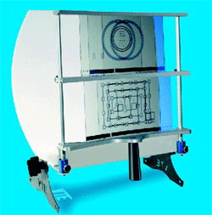

Rotating Pegboard

Addresses visual pursuits, visual motor integration, anchoring, anti-suppression, gross motor integration, and visual discrimination.

Have client begin seated initially with speed setting low. Place pegs (golf tees) in designated shapes one at a time. Once comfortable and consistent, progress to standing and increase variety of input and output.
Progression:
- Begin seated, speed setting to “5”, and placing pegs in interior shapes
- Progress to standing if balance is not compromised. Can progress to balance boards, foam mats, or Dyna-Discs for increased gross motor demands.
- Slowly increase speed with trials with continued success.
- Begin with interior shapes and progress to exterior shapes and overlapping shapes
- Don red/green filtered lenses to address anti-suppression
- Add cognitive stressors when appropriate (patterns, removing every third peg, reading key word response questions, trivia, etc.).
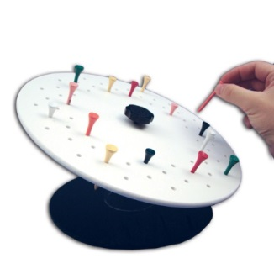
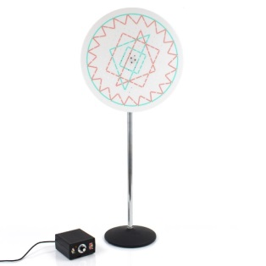

Marsden Ball

Addresses visual pursuits, visual-motor integration, tracking, anchoring, balance, convergence, and peripheral vision awareness.

Begin in supine and visually track the ball in horizontal and vertical pendulum swings, along with clockwise and counter-clockwise rotations. Take breaks as needed. Progress to seated, standing, and finally on balance board, foam, or dynadiscs as appropriate. Can utilize a dowel or bat for bunting specific letters or colors. Encourage a straight forward head posture, only moving the eyes.
Progression for Pursuits and Tracking:
- Begin in supine, progress to seated and then standing
- Add balance board, foam, or dynadiscs for gross motor integration
- Add cognitive challenges (spelling words by bunting letters, color sequences, trivia questions)
- Stand under ball, lower ball to eye level. Throw ball in large diameter circle crossing midline, catch on contralateral side with opposite hand, and throw opposite direction. Do not move head.
Progression for Convergence:
- Can be seated or standing in front of the ball
- Swing the ball toward the client, where the end of the “upswing” would be in front of their chest (without hitting them)
- Have client catch the ball with palms first, moving then to fists, all finger tips, and then only index finger tips
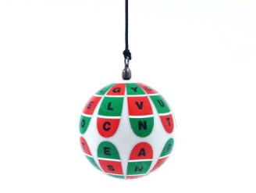
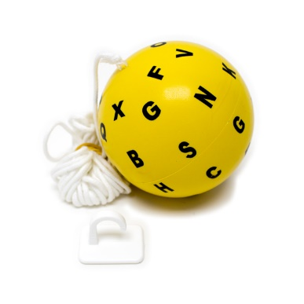
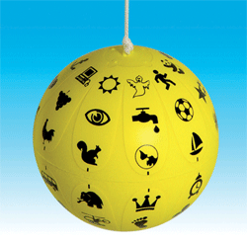

Vision Coach/Dynavision/Wayne Saccadic Fixator

Addresses pursuits, saccades, visual anchoring, visual motor speed, anti-suppression, stereopsis, visual field compensations, and visual inattention.

Input programs to address needed skills. Can be used with balance boards, yoga balls, in sitting, and with cognitive stressors.

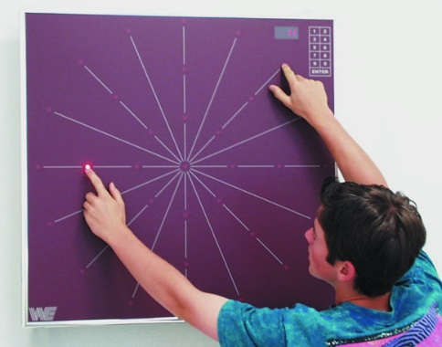
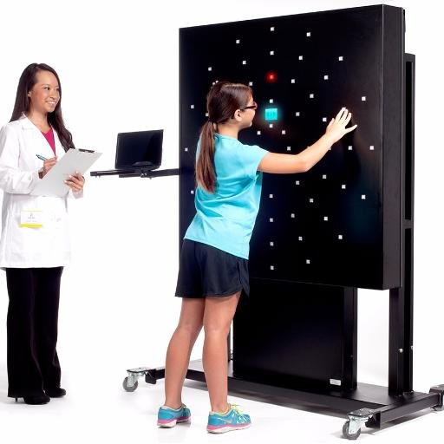

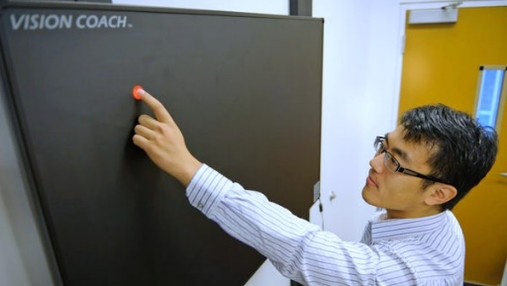

Letter Tracking

Addresses visual tracking, anchoring, scanning, visual motor integration, visual sequencing, visual information processing speed, pursuits, and saccades.

Track line of text, underline or circle alphabet in order. Time trials to increase processing speeds.
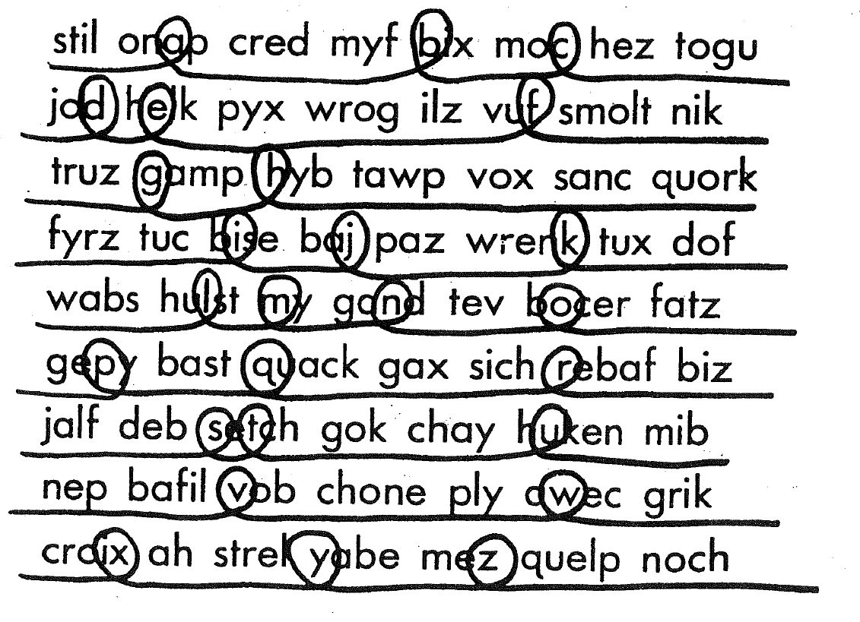

Accommodation Flippers

Addresses near/far accommodation facility and binocularity.

Have client work on a near work task with an accommodative focus (reading, homework, word search, hidden picture, iPad activities, art work, etc.) holding flippers horizontally over eyes/glasses. Start with lowest power flippers (+/- 0.25 or +/- 0.50) and progress through as progress is made and consistency is documented. Flip lenses at timed or random intervals based on accommodation amplitude and sustenance.
Lens Sorting Exercise: Have client don an eye patch initially with reading material appropriate to reading level. Provide with a variety of minus accommodative lenses with at least one diopter difference between lenses. Ask client to get print clear between each lens (accommodative amplitude) and sort lenses based on which required the least amount of effort through the greatest effort required until all lenses are sorted accurately. Completed for plus side flippers, and progress to binocular.
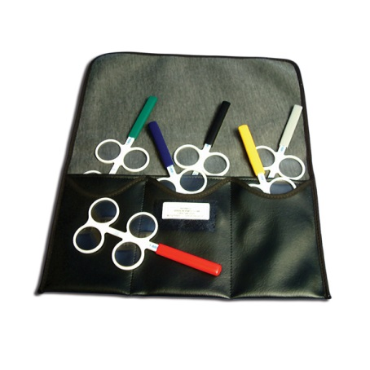

Near/Far Hart Charts

Addresses near/far accommodation, acuity, tracking, and visual anchoring.

Place larger chart on the wall at eye height. Have client hold smaller chart at reading distance and instruct them to stand 10 feet from the far chart. Read the charts line by line, alternating between charts each line. Time for completion.
Hart Chart Saccades: Place two charts on the wall of the same size. Alternate back and forth letter by letter through the charts.
Progression:
- Begin monocularly, progress to binocular when times are consistent or approval from optometrist
- Number or highlight lines to assist with anchoring difficulties
- Start with larger charts at 5 feet. Progress to small charts and increase reading distance.
- Change reading patterns (bottom to top, columns rather than rows, etc.). Have client alternate every 2 letters.
- Call out intersections on far chart and have client identify letter as quickly as possible (ie: what letter is at row 3 and column 2).
- Add a metronome for a rhythmic response.

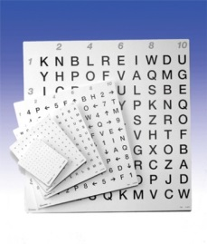

Laterality Charts

Addresses laterality, visual anchoring, and motor integration

Place arrow or tumbling letter chart on wall. Have client stand 10 feet away from wall. Have client recite the direction of the arrows, gesturing direction with correct hand.

Progression:
- Start with level 1 arrow chart, using same side hands for gesturing direction.
- Progress through more difficult levels of charts, using contralateral sides to cross midline
- Use timer to progress processing speeds
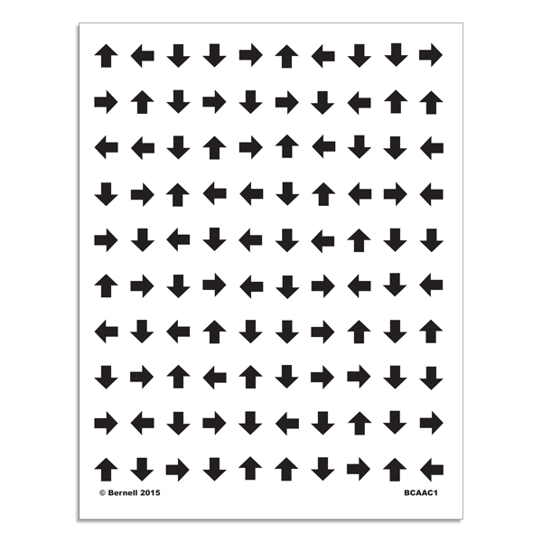
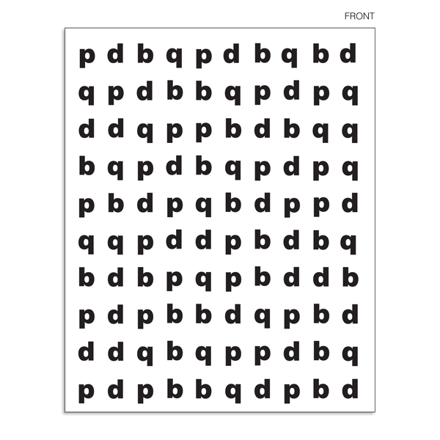

← ↑ → ↓

↑ ↓ ↓ →

← → ← ↑

↓ ← ← ↑

↑ ← → →

↓ ↑ → ↑

← ↑ → → ↓
↓ ↓ → ↑ →
↑ ↓ ↓ → ←
↑ ← → ↓ →
→ ← ↓ ← →
← ↓ ↑ ↓ ←
→ ↑ ← ← ↑
→ → ↓ ↑ →

→ | ← | ↓ | ↓ | → | ↑ | → | ← | ← | ↑
← | ↓ | ↓ | → | → | ↑ | ↑ | ← | ↓ | →
↓ | ↓ | → | ↑ | ← | ↑ | ↓ | ← | ↓ | →
← | ↑ | ← | ↓ | ↓ | ↑ | ↓ | ← | → | ↓
← | ← | ↑ | ← | ↓ | → | → | ↑ | → | ↓
↑ | → | ← | → | ↑ | ↓ | → | → | ↑ | ↑
↓ | ↓ | ← | ↓ | → | ← | ↑ | ← | → | ↑
← | ↑ | ↓ | ↓ | ← | → | ← | ↑ | → | ←
↓ | ↓ | → | ↑ | → | ↓ | ← | ↓ | → | ↓
↓ | → | ← | ↑ | ↑ | ↓ | ← | ← | ↑ | → | ↑ | ↑ | ↓ | →
↑ | ← | ↑ | ↓ | ↑ | ← | → | ← | ↑ | ↑ | ↓ | ← | → | ←
↓ | ← | ← | ↑ | → | ↑ | ↑ | ↓ | ← | ↑ | ← | ↑ | ↓ | ↑
↑ | ↓ | ← | ↑ | ← | ↑ | ↑ | ↑ | ↓ | → | ↑ | ↓ | ↑ | ←
← | ↑ | → | ↑ | ↑ | ↓ | ← | ↑ | ↓ | ↑ | ← | → | ← | ↑
← | → | ↑ | ↑ | ↓ | ← | ↑ | ← | ← | ← | ↑ | → | ↑ | ↓
↑ | ← | ↓ | ↓ | ← | ↑ | ← | → | ↓ | ↓ | → | ↓ | ← | ↓
← | ↑ | → | ← | ↑ | ↓ | → | ← | ← | ↑ | ← | ← | ↑ | ←
← | ← | ↓ | ↑ | ← | ← | ↑ | ↑ | ↑ | ↓ | ↑ | ↑ | ← | ↑
→ | ← | ↑ | ↑ | ← | ↑ | ↑ | ← | ↑ | ↑ | ← | ↑ | ← | ↑
← | → | ← | ↓ | → | ← | ← | ↑ | ↓ | ← | ↑ | ↓ | → | ↓
Small Hart Chart

S  G  J  L  M  P  Z  F  Q  Y | A  H  X  W  D  E  V  B  O  U | I  T  K  F  Q  B  R  I  M  D | O  N  G  Z  A  K  P  L  U  C | Z  F  J  M  I  V  X  E  Y  K | X  P  T  N  C  J  P  Z  R  Q | Q  S  H  O  R  S  M  Y  W  I | J  Y  B  A  P  L  X  G  N  T | K  H  D  Y  Z  F  K  V  C  I | Z  Q  R  E  X  F  C  U  L  P

Medium Hart Chart

I  Q  W  Z  A  B  T  F  L  S | W  H  K  U  P  O  F  R  J  I | G  T  B  D  D  R  E  G  K  C | X  H  R  S  C  W  I  N  Y  D | R  J  D  Z  K  Q  O  I  Q  N | G  N  B  B  X  O  U  W  O  P | J  Z  S  B  V  T  X  U  W  N | N  Q  J  J  X  L  L  V  N  W | T  A  K  N  Y  V  D  O  X  I | Y  F  L  M  A  Y  C  Y  F  Z

Large Hart Chart
N  H  O  M  V  X  A  R  E  Z | B  F  Y  P  L  I  U  V  H  B | C  W  R  K  D  B  Q  G  P  O | K  G  A  X  V  F  D  L  P  J | D  F  S  E  Y  K  A  H  W  I | X  P  T  N  C  J  P  Z  R  Q | L  E  G  H  M  O  Q  F  K  S | J  Y  B  A  P  L  X  G  N  T | W  H  U  D  Z  V  B  Y  O  M | Z  Q  R  E  X  F  C  U  L  P

G | B | A | J | O | L
7 | M | Q | W | P | V
N | X | 9 | A | Z | G
H | Q | B | K | R | E
S | D | J | H | C | Y
T | F | N | A | P | I
U | O | C | Q | X | F
B | U | G | Y | K | L

H | K | 9 | P | N | M
A | B | U | L | F | V
W | Q | 3 | J | D | X
Y | B | E | A | G | R
V | B | W | H | K | A
7 | G | C | R | D | T
Y | 6 | X | K | P | B
M | W | T | B | G | H

abcdefghijklmnopqrstuvwxyz
hfu tairk bie osjdo gue wosamc uol fvqw
difov kefuibmc klscki lopbcs awqwc vpoi
kilgxa whib awncldp kl ripoz wmvls apla
kcgf aoeuga mcbdft dfe jlumn skfna ted
gdwsn cnv ldtau chs ikara xhsmn urbac il
oyewb urfopah nxhsakq yrnw tbha lwaq kl
mshr chgqhj nopam tnbx rhsknm udbur l
hdnvb awxuc ajdhcm iayd ncol jazc yblso
Time: ____
Hsna fkotieb sboaz akja ualcer akcf kcoa
Jamdc uelamv hsbmx aka urlaf aucml laks
Ncajk uagnm clvc aghiug tcnah qreta fsajl
Katcqu mapl sycba yvnau aha cyte beaip a
Nayd ueajjf iapmhd aopn xcyra plamn yro
Bcgaur ncuepv hbanq adjnvi bcnar cjal baj
Habns bnatnv uandg uhn palyd vmnipl wsd
Bamdk sjflkdx afhnu yuipa nvhskair dhfzj
Time: ____

Read aloud underlined letters only
L O Y N T S V Q E H R M P
K S M R B Z D W E J S C A
F T A O N S U R L R J D B
O Y T C S L I W B Z P L W
I T E X J L G D A Q P I C
H F S P I O T M C X Z Q L
O T S R H K P Z N M Q G T
J C S T A S K W R P O Q N
Y H R D S P L M B Y Z S L
K Q P A C V B N W T G D P
L T S N B V X P T K W Z Q
U O P A R H V B Q U V R L
J S A E P M I N H E L A Q
D X Z P O M G L T S L M W
P O R L J V M Z Q R E G S
K Y T R D O B Z A J L P E
I H G V M S R H L K A E P

King Devick’s Saccades

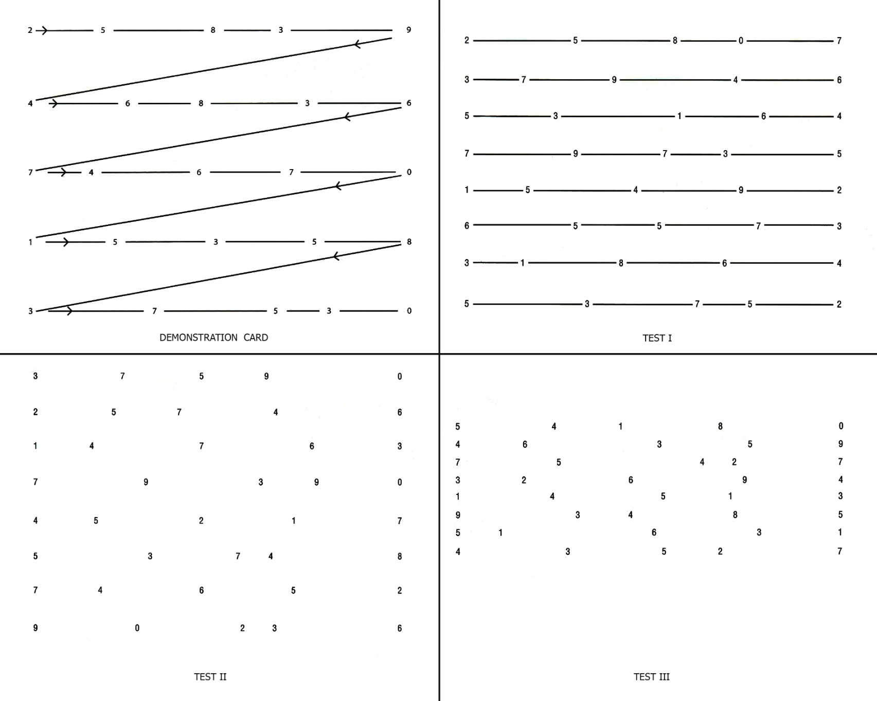

Slap Tap
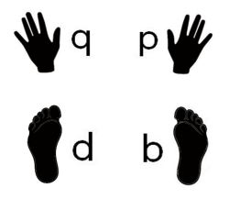

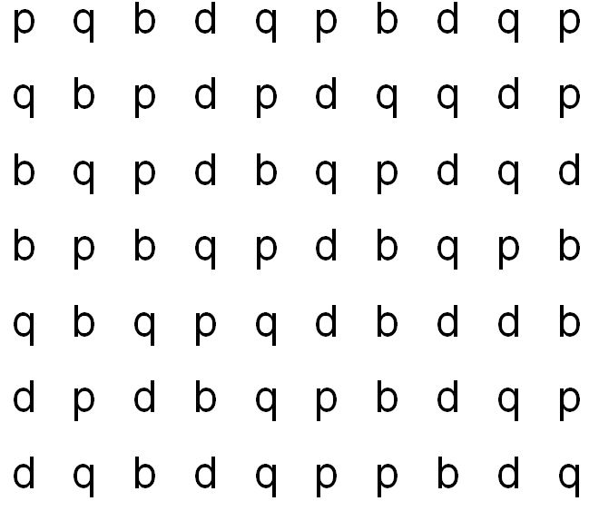

FOUR SQUARE SACCADES
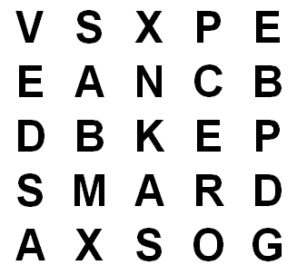
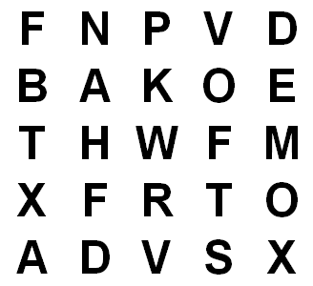

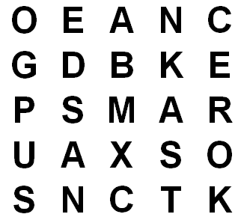
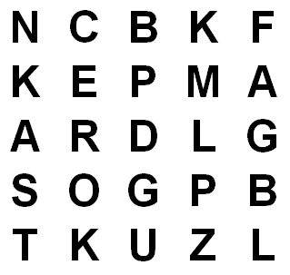
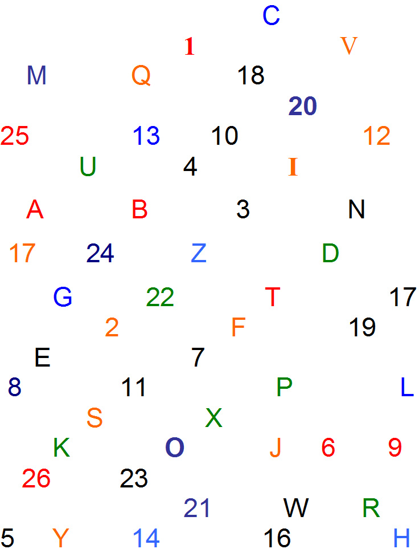

 |  |  |  | 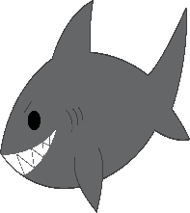
 | 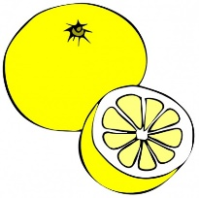 |  | 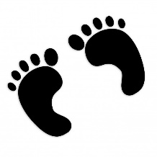 |  | 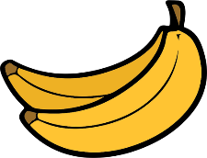
 | 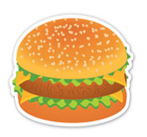 |  | 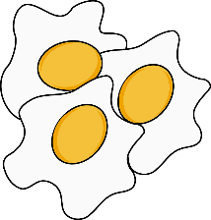 | 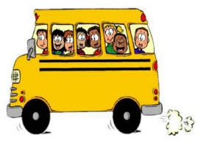 | 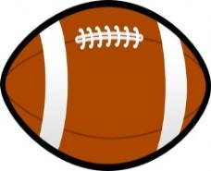
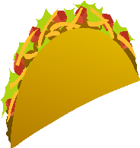 |  | 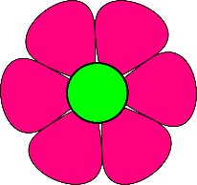 | 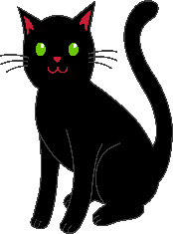
 | 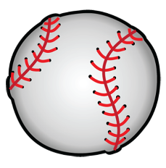 |  | 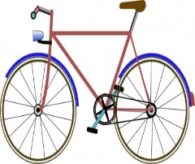 |  | 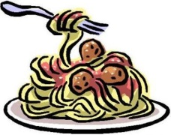
 |  |  |  | 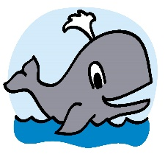 | 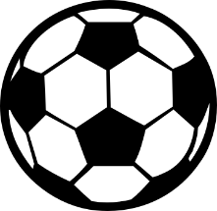
 |  |  |  | 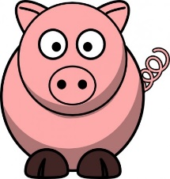 | 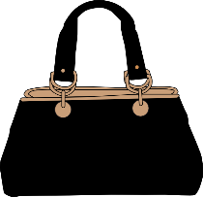
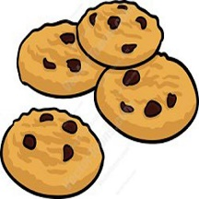 |  | 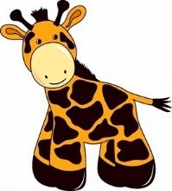

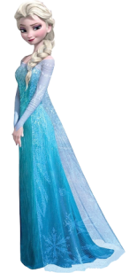
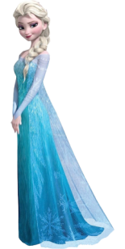

Alpha Numeric Cancellation
8 B 8 8 8 B 8 8 8 B B 8 B 8 B 8 B 8 B B 8 8 B
8 8 B B 8 B 8 B 8 8 B 8 8 B B 8 B B 8 8 B 8 B
8 B B 8 B 8 B 8 B 8 8 B B 8 B 8 B 8 8 B B 8 B
8 8 B 8 B 8 8 B 8 B B 8 8 B B B 8 8 B 8 B 8 B
B B 8 B 8 B 8 B 8 8 B 8 B B 8 8 B 8 B 8 B 8 8
B 8 8 B 8 B 8 B 8 8 B 8 B 8 B B 8 B 8 B 8 B 8
8 B B 8 B 8 B 8 8 B 8 B 8 8 B 8 B 8 8 B B 8 B 8
B 8 8 B 8 8 B 8 B B 8 B 8 B B 8 B 8 8 8 B B 8 B
8 8 B 8 B B 8 B 8 B B 8 8 B 8 B 8 8 B B 8 B 8 B

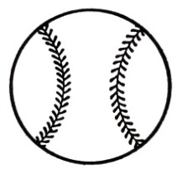
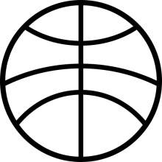
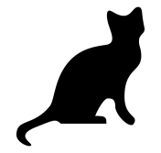
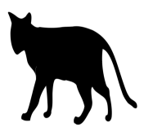

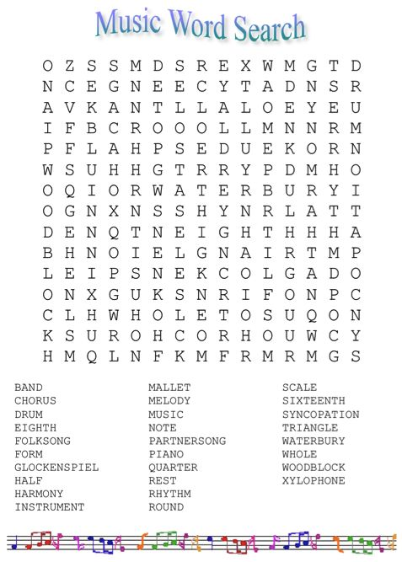

Harry Potter Word Search

X F M X R G Y J I M Z Z E H A R R Y C B F K K V S
D I H B E O G Q T M F A X S I D R G G S Y M C R J
H S K J F H K U O A Z G P R D A M B H R J Y I W F
G J X L N I H T Z C G Q V D O O P L X S O C T R I
J P A R B G T B D K G F I W B Y F P N S N C S C Y
P M F F P O H C I D D I U Q B I T A C X U F M E F
F R F L B Q T E B F U B N O Y W P R L V F P O B H
L G O G U B M O B K K V O L D E M O R T C S O A C
O W N F Y M H G C O P C Z I N V D E R F K L R G O
J O A H E M O V J L R S R C L L P V R P S C B R S
L K E Z K S W S P P V P O P J Q S P K X D V M S S
D H U R L K S S R N I S G A I P G J R T M T G W Z
B I E U G Q X O S S S D M W Z R K Z D G S Y T D C
X Q R H K Y W W R J D H W R T B X U Q I V S H J J
U L J G B V M D D O P D O F Z E F H Y W X L O S Q
L C A A A M O E F I E E W L W I C C B D I J G K W
D X L H N H Z S C I Y X P T A U U X S E M S S Q H
T E Q M Y O T O U B N P P Z D A T J J H H M M B Z
X S O G U F T W S G F Y E C J K D E O M O Q E A B
N V D X N Z F P E H R B E H Y X B G L G U I A J S
Z O H A E M J K O D H G H C W H W G P V J L D U Y
F S R A L C V I T C P Z C G R A P B E V I N E B P
F R L X X T W F U C D Q Y S R M O T T G L M P R R
M T C A B M X A D F R T Z T S L Z A Y H F B O E L
Y Q B S Y N B F Z U G R S R Y L P V U B I E N T U

BROOMSTICK
DOBBY
FRED
HAGRID
HARRY
HEDWIG
HOGSMEADE
HOGWARTS
LONGBOTTOM
LUMOS
MALFOY
PROFESSOR
QUIDDICH
RON
SNAPE
VOLDEMORT
Cross View Images
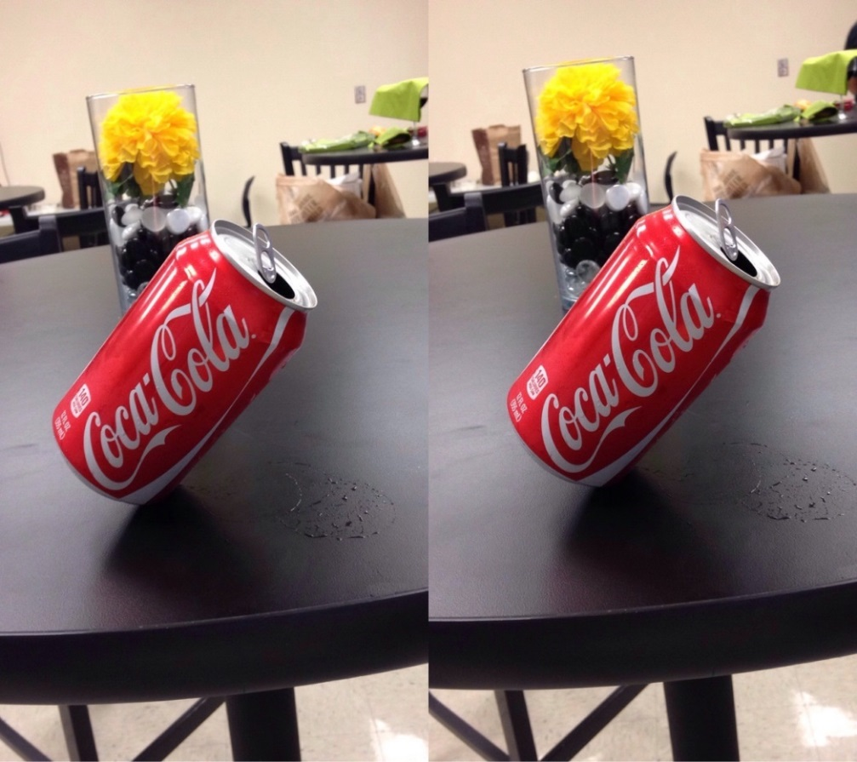

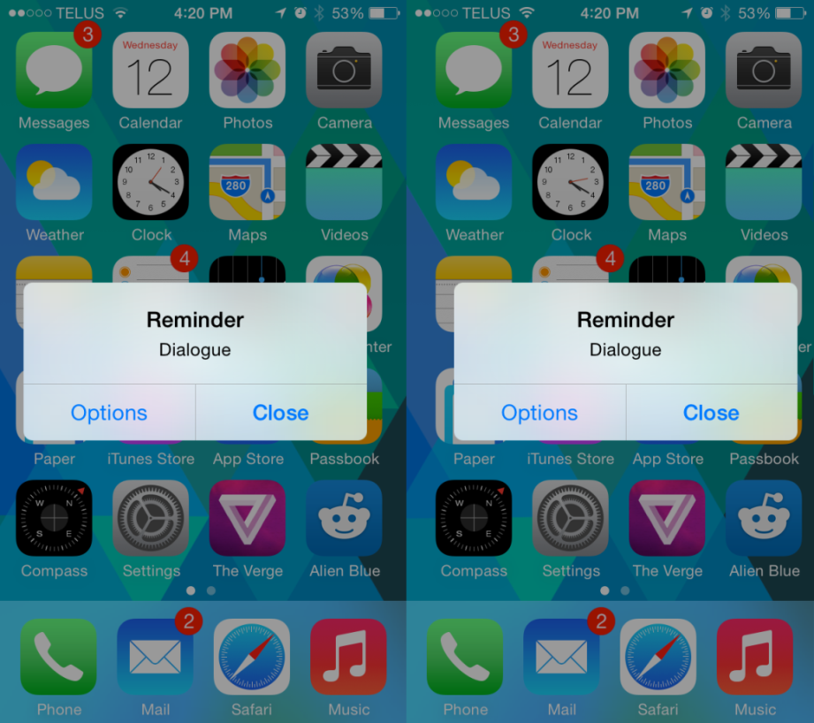

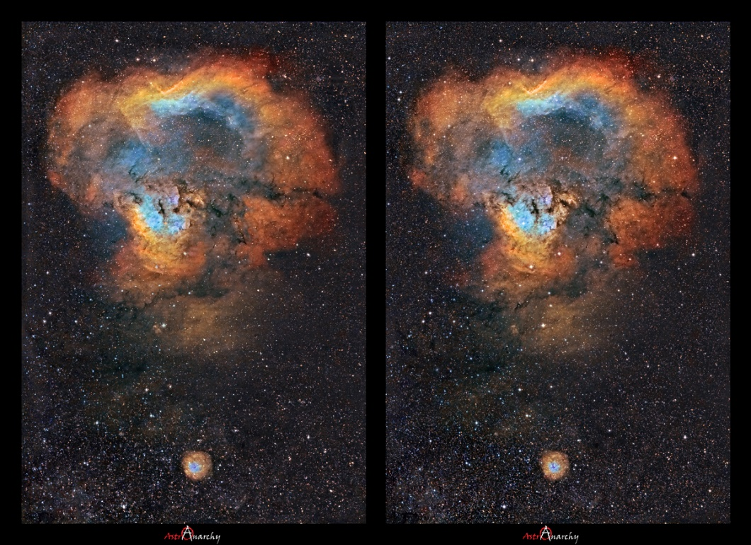

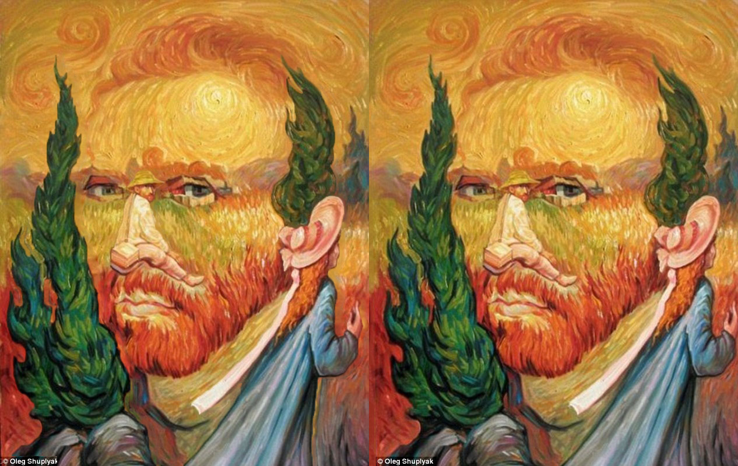

Vision Vocabulary List

Accommodation – The automatic adjustment of the eye for seeing at different distances affected chiefly by changes in the convexity of the crystalline lens; also the range over which such adjustment is possible.
Ambient process – The visual function that allows one to know where s/he is in space, providing him/her with general information needed for balance, movement, coordination, and posture.
Amblyopia – A disorder of the visual system that is characterized by poor or indistinct vision in an eye that is otherwise physically normal, or out of proportion to associated structural abnormalities. Amblyopia is frequently referred to as “lazy eye.”
Asthenopia – The clinical term for eye strain; an ophthalmological condition that manifests itself through nonspecific symptoms such as fatigue, red eyes, eye strain, pain in or around the eyes, blurred vision, headache and occasional double vision. Symptoms often occur after reading, computer work, or other activities that involve tedious visual tasks.
Convergence – Coordinated movement of the two eyes so that the image of a single point is formed on corresponding retinal areas. Successful convergence is observed as the eyes moving in towards the nose as an individual tracks an approaching object.
Depth perception – The ability to determine the relative distance between objects, figures, or landmarks and the observer (i.e. the car in front of you or beside you when driving or parking a vehicle). This skill is also necessary to allow three-dimensional vision.
Diplopia – Another name for double vision, or non-fused images from each eye received simultaneously by the brain.
Esotropia – Inward turning of the eye.
Exotropia – Outward turning of the eye.
Figure ground perception – The ability to visually differentiate between an object and its background, and to visually locate objects that are not well defined.
Fixation – The ability to maintain focus on an object as it is brought to and from the eye.
Focal process – The visual function that allows one to focalize, or concentrate his or her attention, on an object in order to obtain specific information. One may focalize on an object that is located in either his/her central vision (also known as foveal vision) or peripheral vision, but the focal process is most closely associated with foveal vision.
Foveal vision – The narrow and central-most portion of one’s vision that provides the most detailed information.
Form constancy – The ability to recognize the fact that a shape remains the same despite changes in size, direction, shape, and orientation.
Homonymous hemianopsia – Blindness for one half of the field of vision, which produces an inability to receive information from the blind side of the environment. It is not one eye or the other that is affected, but the right or left half of vision in both eyes simultaneously.
Hyperopia – Farsightedness.
Hypertropia – Upward turning or deviation of the eye.
Hypotropia – Downward turning or deviation of the eye.
Laterality – Internal awareness of the right and left sides relative to oneself and another person; laterality also refers to a person’s preference for one side of his/her body over the other side.
Myopia - Nearsightedness
Nystagmus – A form of involuntary eye movement. It is characterized by alternating smooth pursuit in one direction and saccadic movement in the other direction. Horizontal optokinetic nystagmus is a normal (physiological) form of nystagmus that allows a seeing individual to maintain fixation on an object. When nystagmus occurs without filling its normal function, it is pathologic (deviating from the healthy or normal condition). Pathological nystagmus is the result of damage to one or more components of the vestibular system, including the semicircular canals, otolith organs, and the vestibulocerebellum.
Ocular pursuit – The ocular motor skill of following a moving target with the eyes.
Ocular teaming – The ability for both eyes to work together and fuse both images into one image.
Peripheral vision – The part of vision that occurs outside the very center of gaze. There is a broad set of non-central points in the field of view that is included in the notion of peripheral vision. Far peripheral vision exists at the edges of the field of view, mid-peripheral vision exists in the middle of the field of view, and near-peripheral vision, sometimes referred to as "paracentral" vision, exists adjacent to the center of gaze. The peripheral vision is primarily used as a general spatial orientation system, and is largely a function of the ambient process.
Position in space – The ability to perceive and interpret spatial concepts such as over, under, up, down, in, and out.
Presbyopia – Progressive degeneration of ability to focus on near-placed items; a form of hyperopia.
Saccadic eye movement – Eye saccades are quick, simultaneous movements of both eyes in the same direction. Initiated by eye fields in the frontal and parietal lobes of the brain, saccades serve as a mechanism for fixation, rapid eye movement and the fast phase of optokinetic nystagmus.
Size/shape discrimination – The ability to distinguish between various shapes and sizes (i.e. locating the correct size for a bottle).
Spatial relations – The ability to comprehend the relationships of objects in space to one another and to one’s self.

Suppression – The neurological phenomenon of the brain’s ability to disregard information from one eye; suppression frequently results following prolonged double vision, and is thought to be a natural adaptation of the brain to try and make sense of the information received from the eyes. Prolonged suppression may result in amblyopia.
Topographical orientation – Understanding or remembering the relations of places to one another, which permits a person to negotiate space without becoming lost.
Transient channels – A short duration response that shuts off the visual processing of the sustained system. It is triggered by eye movement when we move our eyes from fixation point to fixation point during reading. Transient channels allow the brain to delineate and organize visual information (see visual persistence).
Unilateral visual neglect – Inattention to or neglect of visual stimuli presented in the extrapersonal space on the side contralateral to a cerebral lesion, as a result of visual perceptual deficits or impaired attention. It may occur independently of visual deficits or with the visual deficit hemianopsia. For example, an individual may bump into walls on the affected side of his/her body due to not paying attention to that visual field.
Visual acuity – The capacity to pick out fine details of objects in the visual field both near (e.g. reading a book) and far (reading a street sign). A referral to a neuro-ophthalmologist may be required to determine if corrective lenses and/or specific remedial treatments are needed.
Visual anchoring – The ability to “find you place,” which is required to visually locate the next line within a paragraph that one is reading.
Visual attention – The ability to pay attention visually to specific stimulus in the environment.
Focused visual attention – The ability to focus directly on one particular visual stimulus and ignore all other distractors (i.e. scanning a recipe for a particular ingredient).
Shifting visual attention – Alternating one’s visual attention between two or more visual stimuli (i.e. shifting visual attention between an address in a phone book and the piece of paper that the person is copying it onto).
Selective visual attention – The ability to select particular visual stimuli that are among distractors that may or may not resemble the target stimuli. Strephosymbolia is a type of selective visual attention deficit in which there is a tendency to reverse symbols (i.e. confusing “bad” with “dad”).
Visual closure – The ability to identify forms or objects from incomplete presentations. The ability to perceive and determine that certain parts make a whole or that a whole may be composed or identifiable parts. For example, when searching for scissors in a junk drawer, a person is able to identify the scissors even if they are partially covered.
Visual discrimination – The ability to detect and differentiate between visual features such as color, texture, shape, and size of stimuli. An individual with impaired visual discrimination may not be able to distinguish between the letter “E” and the letter “F”.
Visual field – The field of vision in which a person makes decisions on how to interact with the environment based on what is seen. Visual Field Deficit is an inability to see objects located in a specific region of the field of view ordinarily received by each eye. Often the blind region includes everything in the right half or left half of the visual field.
Visual matching – The ability to determine that two or more objects or colors are the same or are different based on their physical properties (i.e. locating the specific product that one has a coupon for within a store).
Visual-motor integration – Coordinating the interaction of information from the eyes with the body movement during activity (i.e. catching a ball requires the eyes to communicate with the hands to know when to reach and catch the ball).
Visual organization – Utilizing a methodical way of gathering visual information (i.e. left to right, top to bottom).
Visual scanning – Coordinating eye movement in an organized fashion (efficient search pattern) while actively searching the environment for information (i.e. scanning a store shelf for a specific product, reading).
Visual sequencing – Placing visual stimuli in a logical order (i.e. dialing a phone number, following a recipe).
Visual-spatial memory – Refers to the ability to recall visual stimuli in terms of form, detail, position, and other significant features on both a short and long-term basis (i.e. text, geometric figures, maps, and photographs). An individual with impaired visual memory may have to refer to a road map numerous times to reach a nearby destination or may need frequent assistance from staff to locate his/her room.
Visual-spatial processing speed – The ability to process all the information coming in through the eyes at a speed in which the brain is able to register and respond efficiently and accurately. Appropriate visual-spatial processing speed is required to physically respond efficiently and accurately, such as responding quickly when driving a motor vehicle.
Visual persistence – The phenomena experienced when the transient channels of the visual system do not function properly; individuals with visual persistence may report words appear superimposed or overlapping while reading.

